
FIRE MANAGEMENT PLAN
Overview
The mountain and slopes (Table Mountain National Park property) facing Kenrock is a mixture of indigenous and alien species. Pine Trees and Port Jackson abound.
This has not seen a major fire in decades, so the growth is thick.
A fire in 2017 during what was called the ‘Oudekraal Fire’ came as far as the crest of the mountain above Kenrock but the wind blowing up the mountain prevented it from burning the side and slopes. This fire partly burnt Orange kloof to the east
A firebreak has been created running down the mountain to prevent the whole area by Parks Board in 2020.
Kenrock Fire risk areas.
1 Northern boundary shared with national park.
This is protected by a firebreak maintained by the Estate as and when required as well as by the Parks Board on a yearly basis before the fire season.
Outside the Fence
The fence line on the northern boundary is inside the actual property boundary so the pine trees near the gate are in fact on Estate Ground and as such remain the responsibility of the estate.
These trees are a major fire risk as should there be a wild-fire and they catch alight, the resultant sparks may well cause spot fires inside the fence.
Inside the Fence
The pine trees and natural vegetation inside the fence are also a risk factor. Pine trees nearest the fence have been removed as have those closest to the houses in Eagle and Francolin. This area may develop spot fires from flying embers from a fire on the other side of the firebreak

2 Eastern boundary (pine treed properties especially).
This is the area carrying the largest number of Pine trees closest to our boundary.
The southern section from Barn Owl to 8 Falcon has been cleared back for an access road for about 10 m wide so that gives a bit of leeway. However, the neighbour’s properties above 8 Falcon to Eagle Ave. and next to 45 Eagle is heavily wooded,
45 Eagle also has a number of tall trees that create a threat of catching alight from the neighbouring trees.

3 Internal Common property (reeded area at near the dams).
The Bullrushes pose the least fire risk as they are surrounded in the main by grassed areas apart from the border with 4 Cormorant apart from an internal ignition and then sparks resulting in spot fires.
4 Slope facing the gatehouse to north of Kestrel.
This area has by and large been cleared of Pine Trees. Natural vegetation and young indigenous trees cover this area. It is far enough away from the risk of spot fires unless the fire is accompanied by very strong winds.
Action plans to mitigate the risk
1 Northern Border
Currently the trees have been cleared away from the fence and from the area close to 35 Eagle.
Continue the removal of Pine trees.
- Inside the fence
- Outside the fence.
2 Eastern Border.
This is the area carrying the largest number of Pine trees closest to our boundary.
The southern section from Barn Owl to 8 Falcon has been cleared
for an access road for about 10 m so that gives a bit of leeway. The neighbouring properties in the section behind 8 Falcon to Eagle Ave and behind 45 Eagle is heavily wooded.

Remind all residents that making fire on common property is forbidden nor is the dropping of cigarette butts allowed.
Request that owners with pine trees have these removed especially on the fringes.

Fire Fighting Equipment
The estate has the following equipment.
These are kept in the Storeroom security has key or a spare kept in the key-safe (code available from
Estate manager or any trustee).
Beaters 5
Rake Hoes 5
Backpack sprayers 4
A set consisting of
2 rolls of hose 70mm
1 hydrant connection
1 hydrant key
1 nozzle
2 splitters 70mm
4 adapters for 25 mm hose
6 rolls 25 mm hose
4 nozzles for 25 mm hose
In the Grey box behind the storeroom security has a key.
2 rolls hose
1 hydrant connection
I hydrant key
1 nozzle
Radios
6 radios in estate managers office Set to common channel
FIRST AID KIT.
A “mining” first aid kit is kept in the Estate Manager’s Office.
Connection points
On the Northern Boundary there are a number of clip-on garden hose points connected to the boreholes the valve supplying this zone needs to be activated.

PPE
Volunteers that are prepared to act as first responders to act in a fire response need to have:-
Cotton pants (denim jeans)
Suitable footwear. Leather hiking boots ideal
Hat or head covering in non-flammable material e.g., wool or cotton,
Scarf or a means of covering the face again cotton or wool.
Pair of safety goggles available from hardware store
Leather gloves. available from the hardware store, leather welding gloves ideal.
Headlamp for night-time work.

Annual preparation
Fire exercise with all volunteers (November before fire season)
Check all equipment
Check hydrants working.
Check that all vegetation that may be a fire hazard cleared

TYPES OF FIRE AND RESPONSE
WILDFIRES on the mountain (National Park property)

1. FIRE REPORTED / SEEN

2. Contact the City of Cape Town Fire & Rescue Services (CTFRS) – Fire Control – 021 590 1900

3. Please ensure that you supply the CTFRS official with the correct information:
a. Fire Location – as detailed as possible
b. Your name, your present location and contact details
c. Any relevant information such as best access, whether 4WD vehicles are required, any immediate threats or risks

4. Alternative CTFRS – Emergency - contact details:
a. 021 480 7700 (From a Mobile)
b. 107 (From a landline)

5. Contact the TMNP Fire Management Department – 021 689 7438 / 9 – if relevant to TMNP

6. Please ensure that you supply the TMNP official or WoF dispatcher with the correct information:
a. Fire Location – as detailed as possible
b. Your name, your present location and contact details
c. Any relevant information such as best access, whether 4WD vehicles are required, any immediate threats or risks

7. Contact all neighbours that could be either affected or able to assist

8. Deploy your own firefighting resources and personnel or contact your firefighting agent if applicable

9. Put out the fire, if within scope of ability, while allowing for SAFETY first

10. Protect infrastructure prioritising in the following order:
a. Life safety
b. Asset / infrastructure protection
c. Environment

11. Contact the CPFPA if necessary – 021 689 7438 / 9

12. Open all necessary gates and access points for firefighting agencies

13. Provide maps of the property if necessary and available

14. If time allows and available, initiate all relevant water hydrants or water points

15. CTFRS and other agencies arrive on the scene

16. CTFRS assumes command of the scene

17. Landowner / property representative / property firefighting team / firefighting agent to report to the CTFRS Incident Commander (IC) and comply with all instructions.

18. Depending on the size and complexity of the wildfire, the IC might initiate an Incident Management Team (IMT) where the IC may activate a Liaison Officer. This person will then become your point of contact. Alternatively, a CPFPA representative might assume this role.

19. The CTFRS Divisional Commanders (or their superiors) or TMNP Fire Manager will determine whether aerial support is required and dispatch if necessary. The IC will determine what resources are required for the wildfire.

20. Assist where required. The IC may well stand you and/or your team down.

21. Inform the IC / Liaison Officer when you wish to stand down. Communication with the IC is critical.

22. Advisable and if necessary – contact Enviro Wildfire Services to conduct a preliminary wildfire investigation – 083 411 3378 – within 6 hours of ignition – this preliminary wildfire investigation is offered free of charge for all CPFPA members. Alternatively, please contact the CTFRS’s Fire Safety Division at the nearest Fire Station to request an investigation.

EXPANSION OF POINT 8 ABOVE

See next page
Keep teams supplied with necessary supplies
Keep in touch with fire leader as to the status
Open Hydrants
Fight fire
Go to allocated area
Get Equipment
Team leader
+ 3
Keep track of fire and progress
Assess situation
Allocate areas to team leaders
Keep residents informed.
HOUSE FIRES
Remember
- Fire is FAST! In less than 30 seconds a small flame can turn into a major fire. It only takes minutes for thick black smoke to fill a house or for it to be engulfed in flames.
- Fire is HOT! Heat is more threatening than flames. Room temperatures in a fire can be 100 degrees at floor level and rise to 600 degrees at eye level. Inhaling this super-hot air will scorch your lungs and melt clothes to your skin.
- Fire is DARK! Fire starts bright, but quickly produces black smoke and complete darkness.
- Fire is DEADLY! Smoke and toxic gases kill more people than flames do. Fire produces poisonous gases that make you disoriented and drowsy. Asphyxiation is the leading cause of fire deaths, exceeding burns by a 3-to-1 ratio.

Contact the fire Department
Give them clear details of the address where the fire is and tell them it is on Kenrock.
Fight the fire as a first responder
If the fire is small and you think you can safely fight the fire using either a fire extinguisher or hose aim for the base of the flames. Even a garden hose is effective until you can
retrieve the firehoses hydrant key and coupling from the store or grey box.
Connect to the hydrant and fight the fire from a safe distance. Take heed of rules below.
A trapped person just creates more problems and risks other lives.
RULES
FIGHT OR FLIGHT
Fire becomes more dangerous by the second. If you can't fight it immediately, when it's safest, you have a hard choice to make.
Firefighters advise that evacuation comes first if there are others that need care such as the physically impaired or children.
The time-tested rule holds: Once you've got everybody out, don't go back, even if that means consigning your house to the flames.
Also, evacuate when any of the following occurs:
If you are using a fire extinguisher or hose and: -
A. The extinguisher is out but the fire is not.
B. You sense that it's a lost cause, even if the extinguisher still has extinguishing agent left and the hose is still working.
C. The room is filled with smoke.
D. It appears that the fire is going to block your exit at any moment. Remember, you always fight a fire with your back to a clear exit. Never let flames get between you and your way out. If need be, clear the exit path, then get out.

Fire water points attached to borehole water supply
A number of clip-on hose points are positioned along the northern boundary for use in event of a fire occurring on the northern boundary.
These are marked on the fence line with yellow paint.
Turn on the valve painted red on the inside of the fence. To increase pressure, get the owners on the fence line to close their borehole feed. This will stop their tanks filling leading to a reduction of pressure.
Clip on a (Gardena fitting) normal garden hose to fight the fire if required.

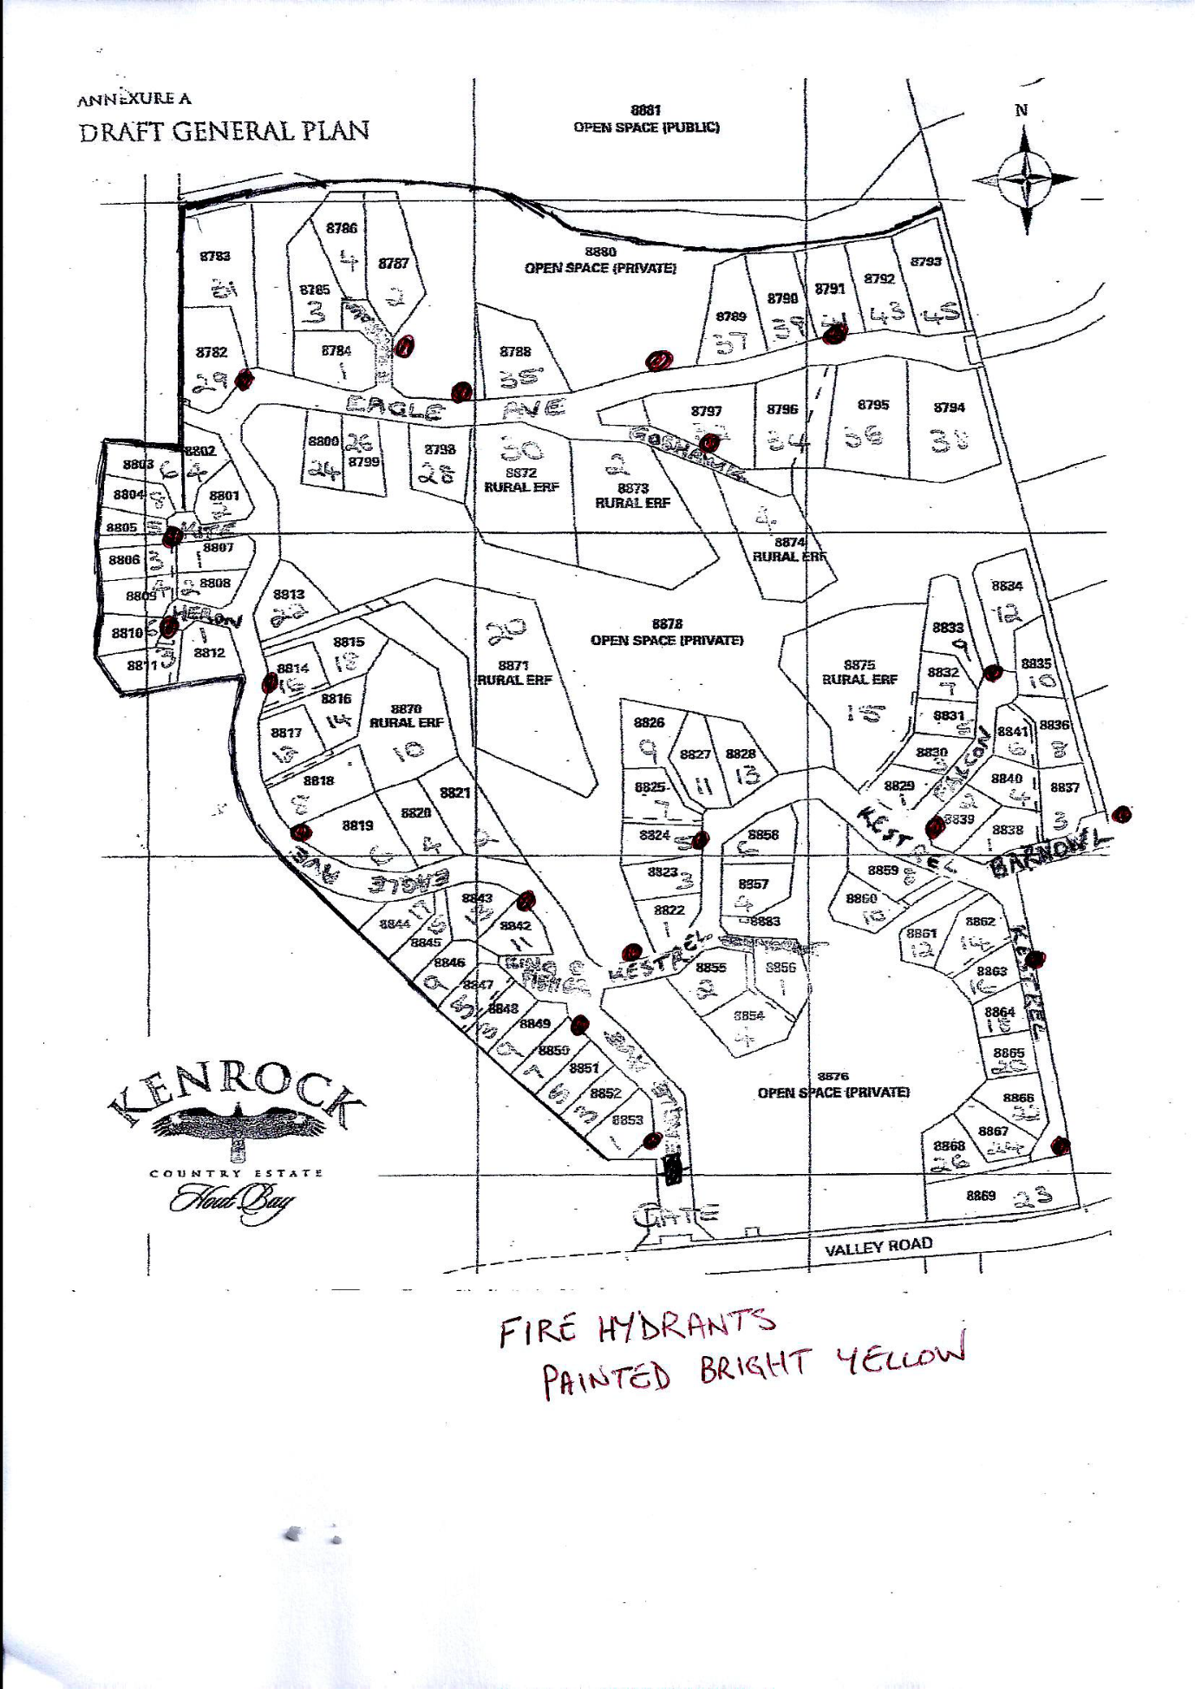
FIRE HYDRANT POSITIONS
Fire Hydrants painted bright yellow

